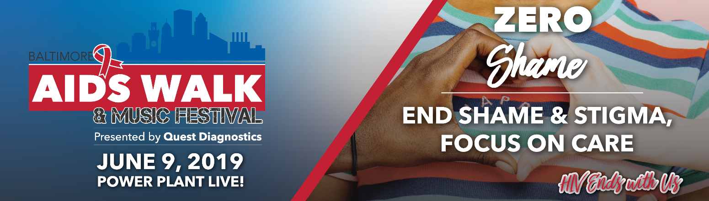

I’m raising funds for the Baltimore AIDS Walk!
I am excited to let you know that I am participating in the 2019 Baltimore AIDS Walk. I have set a fundraising goal of $_______________!
Would you please consider sponsoring me to help reach my goal?
The money we raise will ensure that Chase Brexton and its Community Partners can continue to provide crucial programs and services to those living with or affected by HIV and AIDS in Baltimore.
To sponsor me online, go to tinyurl.com/BMoreAIDSWalk , scroll down to “Search Participants” [on the right side of the page] and type in my name. From there, you can donate directly to my personal fundraising page.
You can also sponsor me by check. Simply complete the form below, detach, and mail it to the Baltimore AIDS Walk office with your check enclosed (see address below).
All donations are tax deductible. Chase Brexton Health Care’s Tax ID#/EIN is 52-1638592.
Many thanks!
Chase Brexton Health Care
Attn: Development
1111 North Charles Street
Baltimore, MD, 21201
------------------------------------------------------------------------------------------------------------
NAME______________________________________________________________________________
ADDRESS___________________________________________________________________________
CITY____________________________________STATE____________ZIPCODE___________________
ENCLOSED IS MY TAX-DEDUCTIBLE CONTRIBUTION OF $ ____________________________________.
PLEASE MAKE CHECK PAYABLE TO: CHASE BREXTON HEALTH CARE
Please enter my name in the memo of the check so I will receive credit for the donation!
Thanks again!

