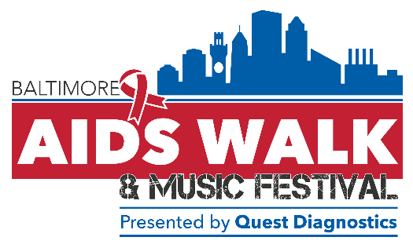
Hello Neighbor!
My name is _______________________________________________.
On Sunday, June 9, I will be joining hundreds of other compassionate people who have committed to raising awareness and helping those living with HIV and AIDS at the 2019 Baltimore AIDS Walk & Music Festival.
I hope you will consider sponsoring me in this important fight!
Option 1 - If you would like to sponsor me online:
⇒ Go to baltimoreaidswalk.org
⇒ Click the “Register Now” button
⇒ Scroll down to “Search Participants” [right hand side of the page] and type in my name.
⇒ Click “Donate Now” button
⇒ Follow the directions to make a secure donation online.
Option 2 - If you would like to sponsor me with a check or money order:
⇒ Make the check payable to “Chase Brexton Health Care.”
⇒ Write my name in the memo of the check for the donation to be applied to my fundraising goal.
⇒ Drop by to give me the check or call me to pick it up. My phone number is _____________________.
Where does the money go?
With your support, we can end the impact of HIV on our friends, families, and our communities, by expanding education, testing, prevention, and treatment programs provided by Chase Brexton and our Community Partners that pledge to change the course of HIV and bring it to zero. Your donation is tax-deductible as a 501(c)(3) charitable contribution.
To learn more about Chase Brexton’s HIV and AIDS services, please visit tinyurl.com/CBHCHIVCare.
To learn about this year’s AIDS Walk Community Partners, please visit tinyurl.com/BMoreAIDSWalkPartners.

Thank you so much for considering my request!
For more information about the Baltimore AIDS Walk & Music Festival, visit baltimoreaidswalk.org or call 410-837-2050 x1034

